# 3D Printing Summary

|  |  |
| --- | --- |
| **Metrics** |  |
| Total Print Time (min) | 508 |
| Total Number of Components | 2 |
| Typical Total Mass (g) | 92 |
| Typical Number of Print Setups | 2 |

# 3D Printing Settings

|  |  |  |  |  |  |  |  |
| --- | --- | --- | --- | --- | --- | --- | --- |
| **Print File Name** | **Qty** | **Total Print Time (hr:min)** | **Mass (g)** | **Infill (%)** | **Support(Y/N)** | **Layer Height/ Nozzle Diameter(mm)** | **Notes (orientation, special settings, etc.)** |
| aid-top.stl | 1 | 4:16 | 30 | 20 | N | 0.2/0.4 | * Print in orientation given in STL |
| aid-bottom.stl | 1 | 4:16 |  | 20 | N | 0.2/0.4 | * Print in orientation given in STL |

# Customization Options

* The device can be printed in any colour the user would like
* The device can be scaled to fit the hand of the user

# Post-Processing

* Remove any sharp edges with a hobby knife or sandpaper
* Using a soldering iron, ‘weld’ the two pieces together as described in the assembly guide.

# Examples of Quality Prints

**Photos of aid-top**

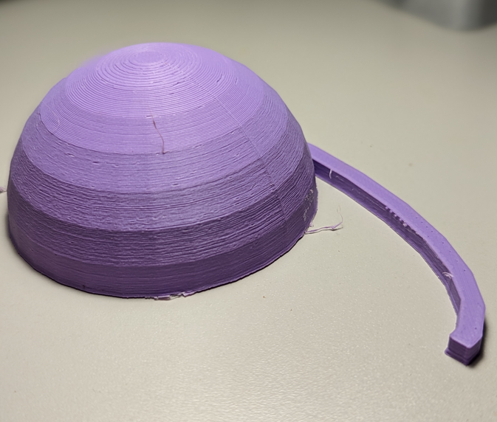

**Photos of aid-bottom**

